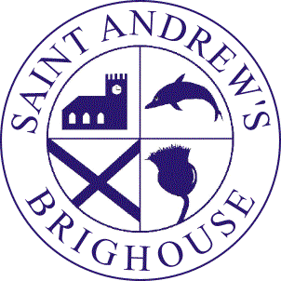After School Kids Club
Booking Form

Child’s name ……………………………………………………………………………

Sessions required (please tick)

Monday | Tuesday | Wednesday | Thursday | Friday

Start date: …………………………………………

Current fees are £9 per session. If two or more siblings attend a reduced fee of £8 per child applies.

Terms and Conditions of Use

- I understand that fees are payable monthly in advance.
- We will invoice you each month. Fees must be paid no later than the first Monday of each month.
- Your child may lose their place in the After School Club if payment is not promptly received.
- We reserve the right to charge an additional administration fee if your cheque is not accepted by the bank.
- You must pay for any sessions booked even if your child does not attend due to illness or for any other reason.
- You must give one month’s notice if you no longer require a place in the After School Club.
- We will give you at least one month’s notice of changes to fees or cancellation of the service.
- We may terminate this agreement without notice at any time if your child does not comply with the School’s Behaviour Policy.
- The After School Club closes at 6.00pm. If for any reason I am going to be late I will contact Kids Club as soon as possible.
- If my child is not collected by 6.00pm I understand that I will incur a charge of £5.00 for every 10 minutes to cover the costs of the staff that are required to stay behind to supervise my child.
- If my child still remains at 6.30pm and the club has been unable to reach me or any of my emergency contacts, I understand that the Club will follow its Uncollected Child Policy and may contact Social Services.
- Whilst we try to ensure the safety and security of items, we cannot be held responsible for anything lost or stolen.
- If my child has an accident then he/she will be treated by a qualified first aider and I will be informed as soon as possible.
- If there is a situation where my child needs urgent medical treatment (medication/ X-ray) or medical advice and I am unavailable, a member of staff from the After School Club may sign any necessary consent forms on my behalf.
- Where the School has endorsed my claim for Tax Credit, we are legally obliged to notify the HMRC if I cease to use the service during the period of my claim unless I give a minimum of 10 days notice. Your Tax Credit claim form will indicate that we may be held jointly liable for any claim HMRC consider to be fraudulent.
- I understand that aggressive or abusive behaviour will not be tolerated.

I have read and understood the above terms and conditions and agree to abide by them.

Signed: ………………………………………… Date: …………………………

Parent or carer’s name ………………………………………………………………..

