How to comment and Blog on Purple Mash
- Click on the sharing icon at the top and click on which blog you want to comment on.

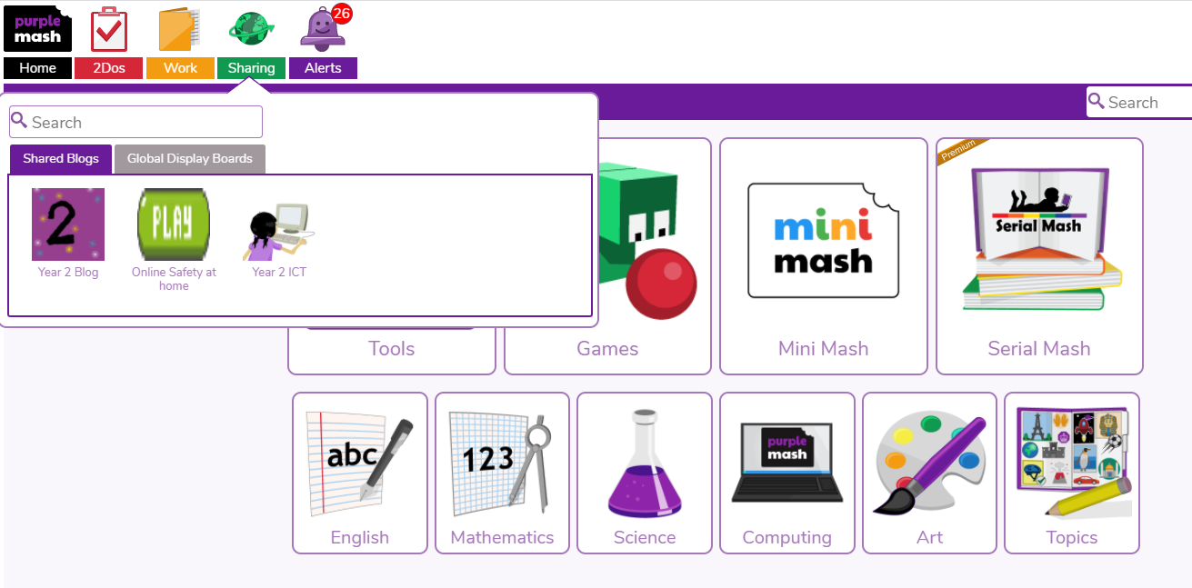

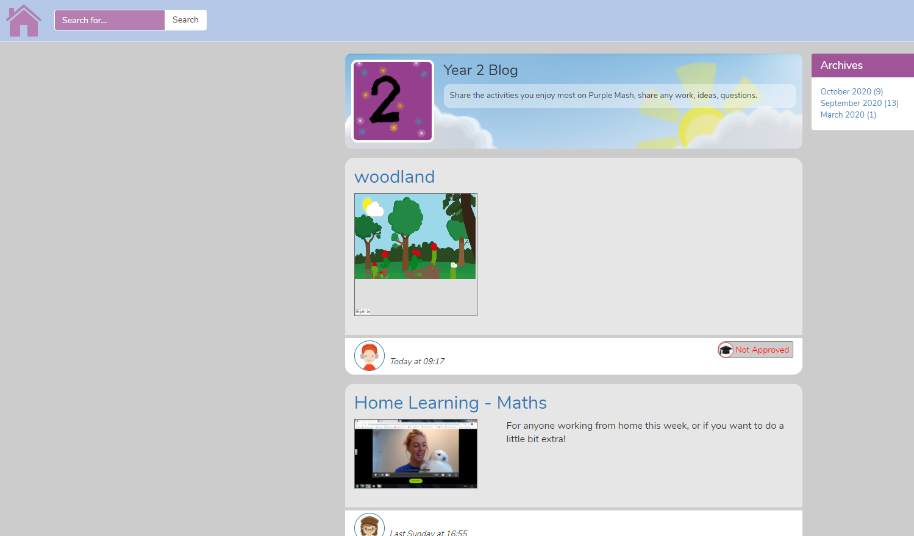
- This page will show, then click on which blog you want to comment on.

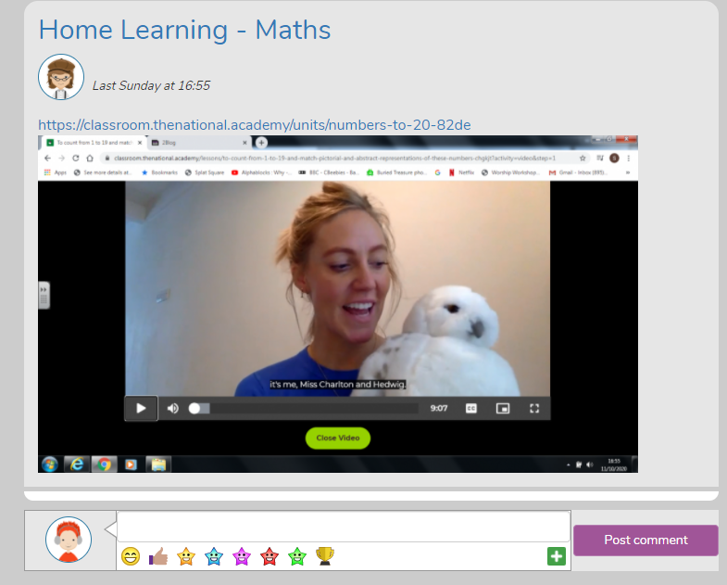
- Write your comment, then post.

- If you want to add your own blog, same thing as before click on the sharing icon at the top, choose a blog, then this time click on the plus icon at the top right hand side.
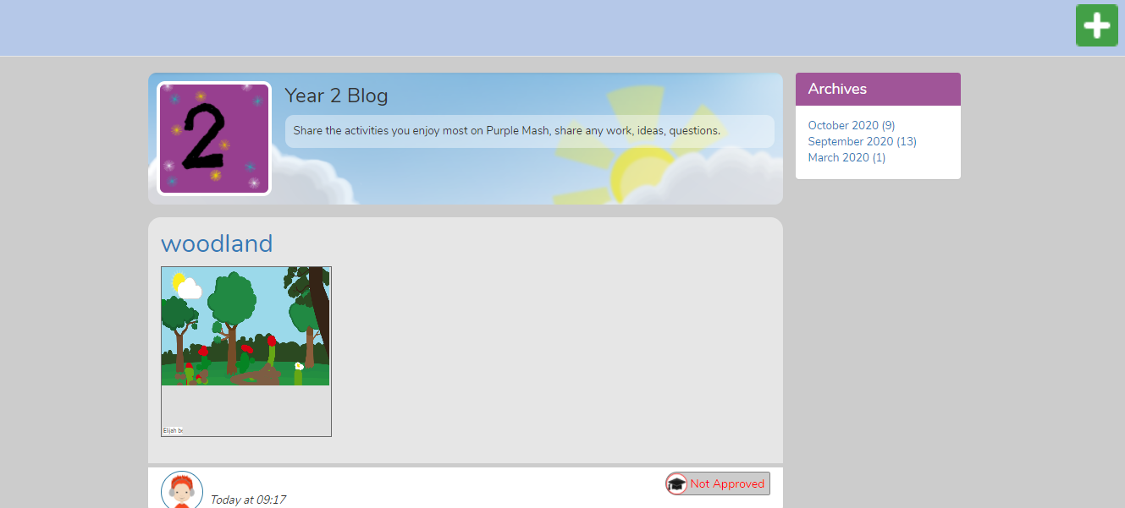
- When you have clicked on the plus icon, this image shows up. You can then add a title, summary, picture, video or work. Then click on the save and publish button at the bottom.

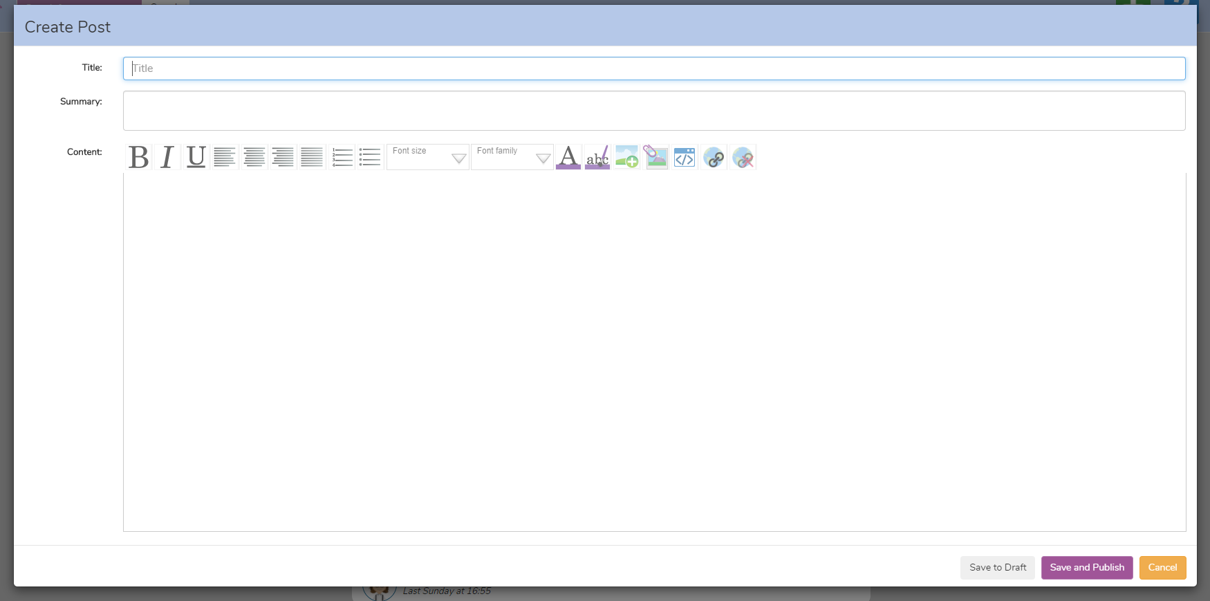

The blog will to be checked by a member of staff before it is approved and appears for all your class to see.

Happy blogging
Miss Kerry

