How to send work to a teacher using 2Email on Purple Mash
- Once your child has signed in, click the search bar on the homepage as shown below:
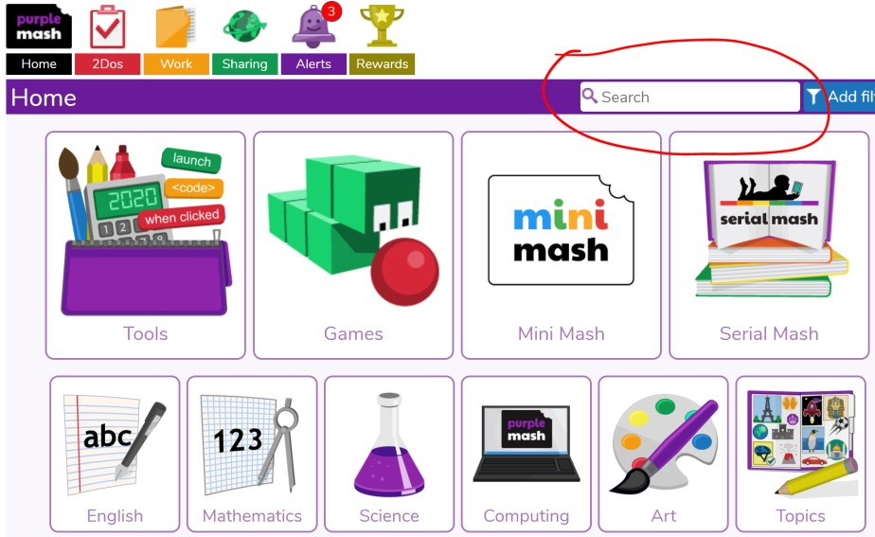
- Type ‘2email’ and then click on the 2email icon:
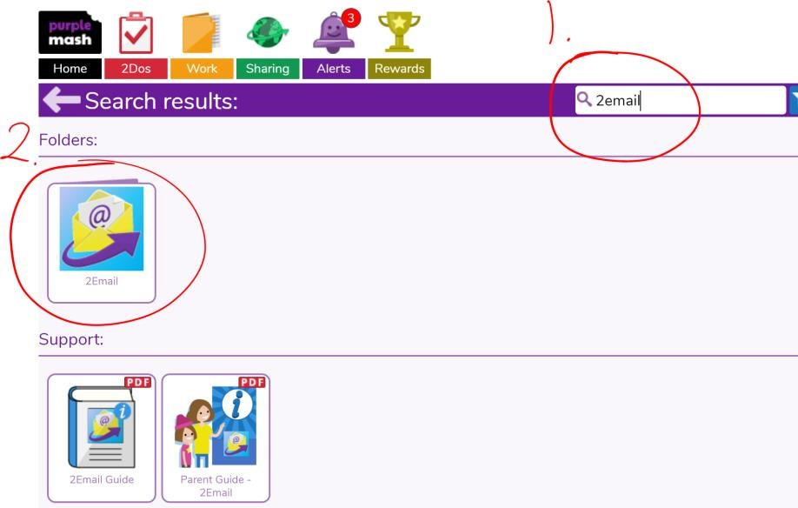
- Again, click on the 2email icon:
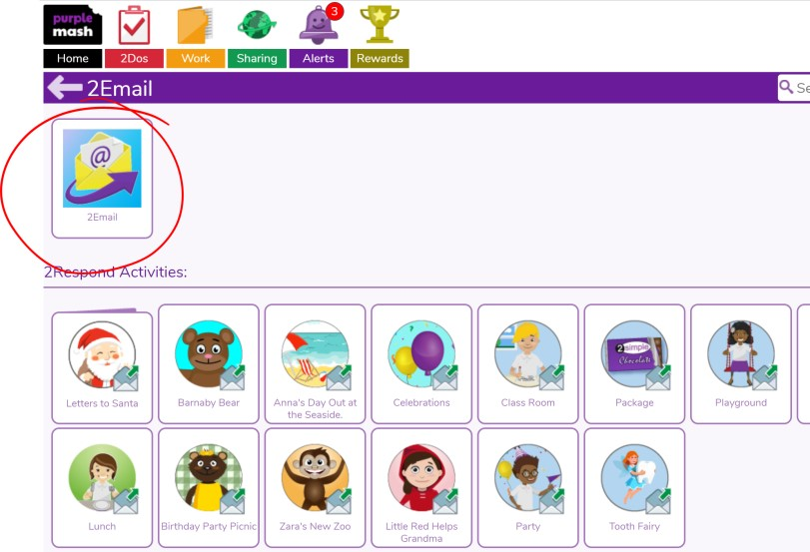
- You can now email work by replying to the teacher’s email OR by composing a new email. The way to attach a document/image is the same for both options. Here are instructions on how to send a document from a new email:
Click on the envelope with a green + sign.
- Click ‘Attach file.’
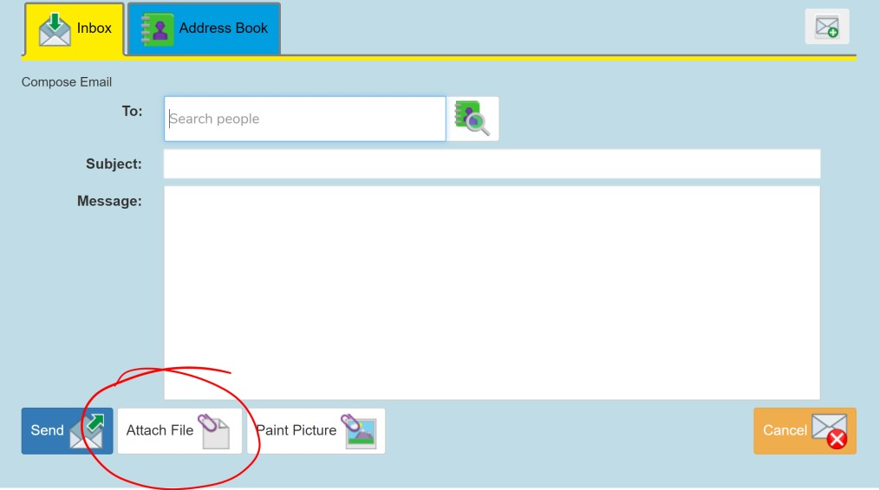
- Locate and double click the document/image from your computer.
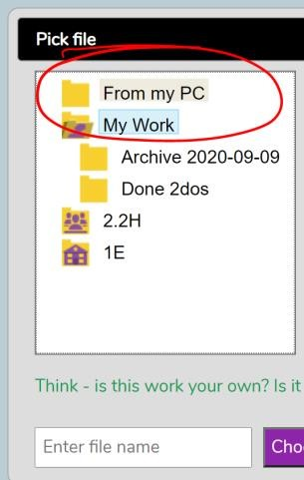
- Once you have attached the relevant files, click send:
