St Andrew’s CE (VA) Infant School – School Menu Card - 1 week rota
Name:
Class:
January 2021 – April 2021

Week 1 ALL MENUS SUBJECT TO AVAILABILITY OF PRODUCE
Mains – tick 1 (√) | Monday | √ | Tuesday | √ | Wednesday | √ | Thursday | √ | Friday | √
 | Breaded Chicken  Chips  Salad |  | Spaghetti Bolognese  Garlic Bread  Sweetcorn |  | Roast Turkey & gravy  Mashed potatoes  Peas  Carrots |  | Korma  Rice  Broccoli |  | Sausage Penne Pasta  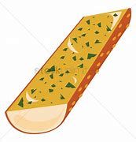  Garlic Bread  Salad
 | Pizza  Chips  Salad |  | Fish Fingers  Garlic Bread  Sweetcorn |  | Vegetable Ravioli  Mashed potatoes  Peas  Carrots |  | Fishcake  Broccoli  Potatoes |  | Cheese Wheel  Waffles  Beans
 | Ham OR Egg (v) OR Cheese (v) Sandwich, (please circle which option) potato and salad |  | Cheese Toastie and salad |  | Tuna soft roll baguette and salad |  | Ham OR Egg (v) OR Cheese (v) Sandwich, (please circle which option) potato and salad |  | Ham OR Egg (v) OR Cheese (v) Sandwich, (please circle which option) potato and salad
tick 1 (√) | Orange Shortbread |  | Ginger Biscuit |  | Chocolate Shortbread |  | Banana Cake |  | Flapjack
 | Yogurt |  | Yoghurt |  | Cracker, cheese and grapes |  | Yogurt |  | Yoghurt
 | 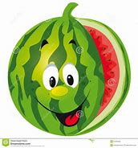  Melon Slice |  | Orange |  | Apple |  | Fruit Salad |  | Fruit Platter

We WILL change your child’s menu if they are not happy with their choice. Please contact the office if you have any queries.

